ST10454581

Daniel Casimiro Alcantara Prazeres

WEDE5020

POE Part 1

Table of contents:

Introduction

Assets

Website pages and Content

Introduction:

NGO/NPO choice

A video game developing and publishing company that funnels video game sales into charity donations and through the themes of their games pushes players to get involved with non profit work. The name of the company I've created is Dead Pixels named after the phenomenon of pixels on monitors not functioning and leaving black spots, which is evocative of the societal issues that the company makes games about, with respects of the order of society being disrupted by issues that cause holes within the fabric of peace. I've chosen to create a simple website for a video game company that makes and publishes games with a focus on using profit from sales to donate to charity’s. The company dead pixels would partner up with a plethora of charities when creating games, which is advertised on the games webpage as well as the percentage of sales that goes towards donations and which charity that the money is being donated to. Moreover games produced by dead pixels feature themes of mental health, economic issues and damage to the environment in order to empower players to help within their local communities, charity drives and nature cleanups. Moreover the company sponsors charity events which are advertised on the homepage of their website. The company hires programmers as well as relying on programmers to lend their services and expertise as volunteers. Moreover the company also advertises games made by other developers that also donate to charity and have similar themes to Dead Pixels games. The purpose of the website for Dead Pixels is to promote both games they have made and games that they believe have good intentions from other Studios, to act as a platform for potential hires and volunteers to apply to the company for positions. Thirdly the website acts as a place for individuals to find information on the company Dead Pixels, such as their mission, date of creation and current members. Lastly it acts as a place for customers to get help in case of issues with purchasing games, or bugs found within games.

Assets:

The IEE. 2024. The IIE Harvard Style Reference Guide - Adapted for The IIE 2024-f52fbd5a. The Independent Institute of Education: Unpublished.

The IEE. 2024. WEDE5020/d/p/wMODULE MANUAL/GUIDE[WEDE5020 Module Manual] The Independent Institute of Education: Unpublished.

Website Pages and Content:

Schematic for the design of the webpages

### Home page:

Text saying “Home page”

Logo that is a button which takes you to the home page

Name of company with a trademark character next to it

Vertical link bar

Short paragraph about the company

Heading reading “Newest game: Between flesh and steel” that when clicked takes you to the games webpage

A short paragraph explaining the premise of the game and its gameplay

An image of the game that when clicked takes you to the games webpage

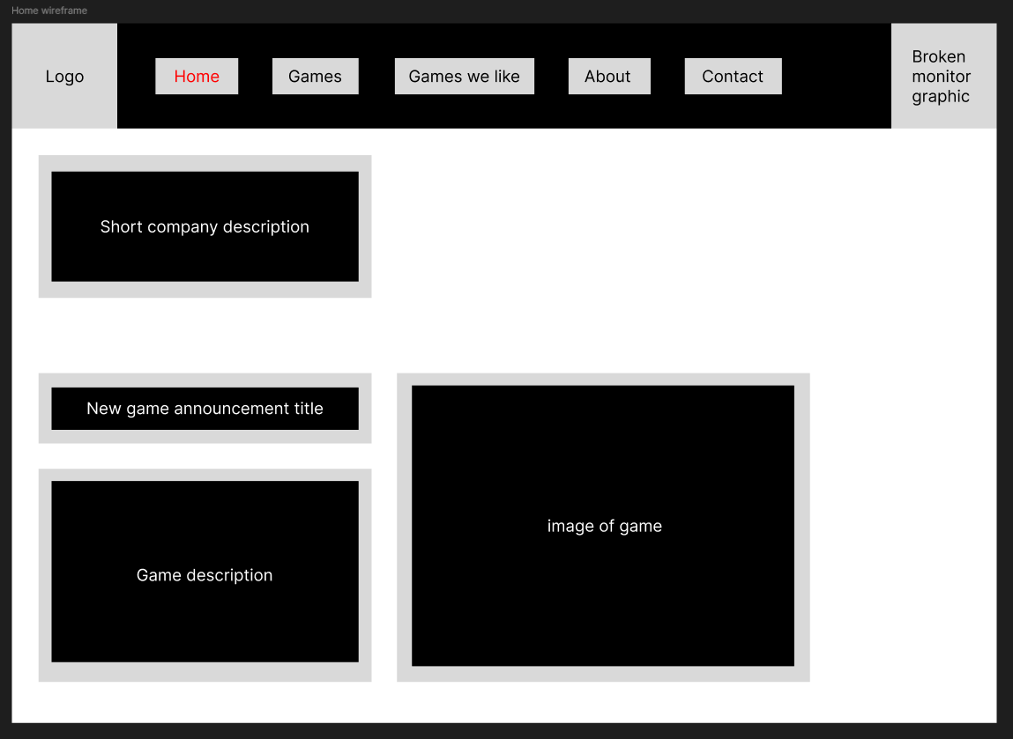

### About page:

Text saying “About page”

Logo that is a button which takes you to the home page

Name of company with a trademark character next to it

Vertical link bar

Text saying “About us”

Description of the company, Its purpose and goals

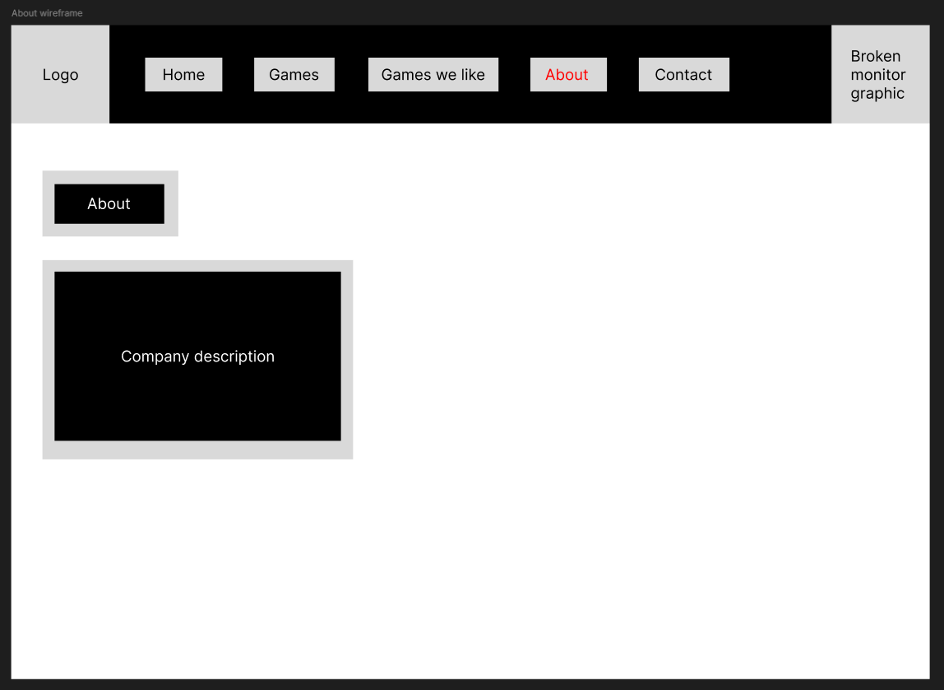

### Contact page:

Text saying “Contact page”

Logo that is a button which takes you to the home page

Name of company with a trademark character next to it

Vertical link bar

Text saying “For business related enquiries”

Company business email

Company business phone number

Text saying “Customer support”

Company customer support email

Company customer support phone number

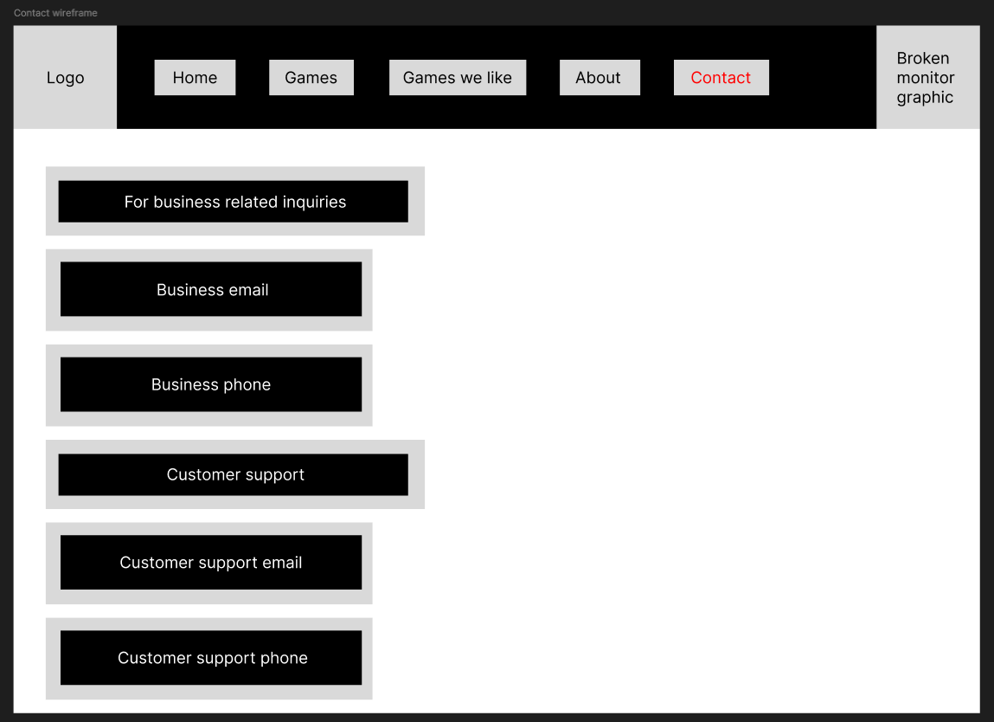

### 

### Games page:

Text saying “Games page”

Logo that is a button which takes you to the home page

Name of company with a trademark character next to it

Vertical link bar

A subheading reading “Between Flesh and steel”

A paragraph detailing what the game is about, what the mechanics of the game are and some story elements

An image of the game detailing its gameplay

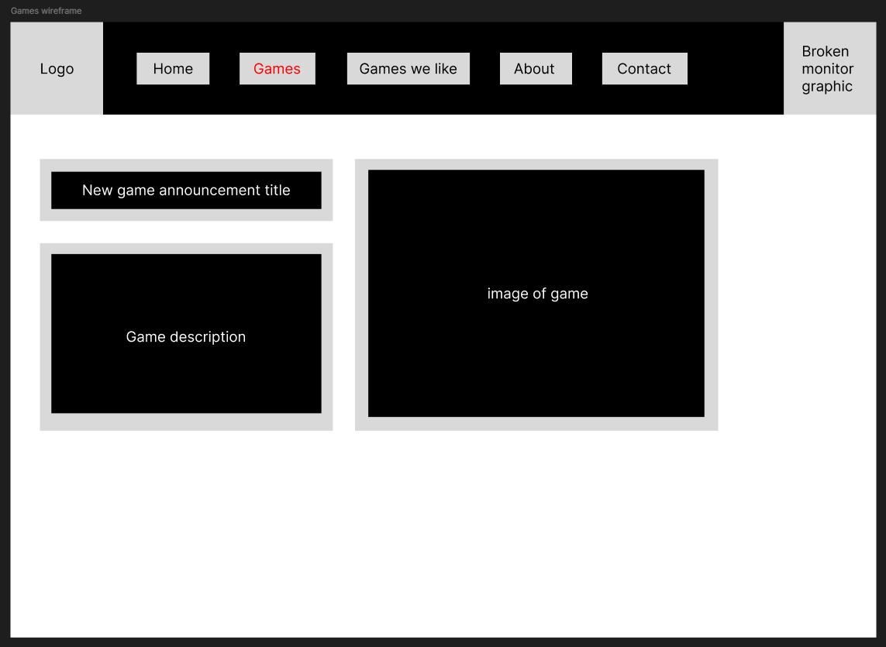

### Games we like page:

Text saying “Games we like page”

Logo that is a button which takes you to the home page

Name of company with a trademark character next to it

Vertical link bar

A subheading reading “Neo dystopia”

A smaller subheading reading “A game by Red Rabbit productions”

A paragraph detailing what the game is about, what the mechanics of the game are and some story elements

An image of the game detailing its gameplay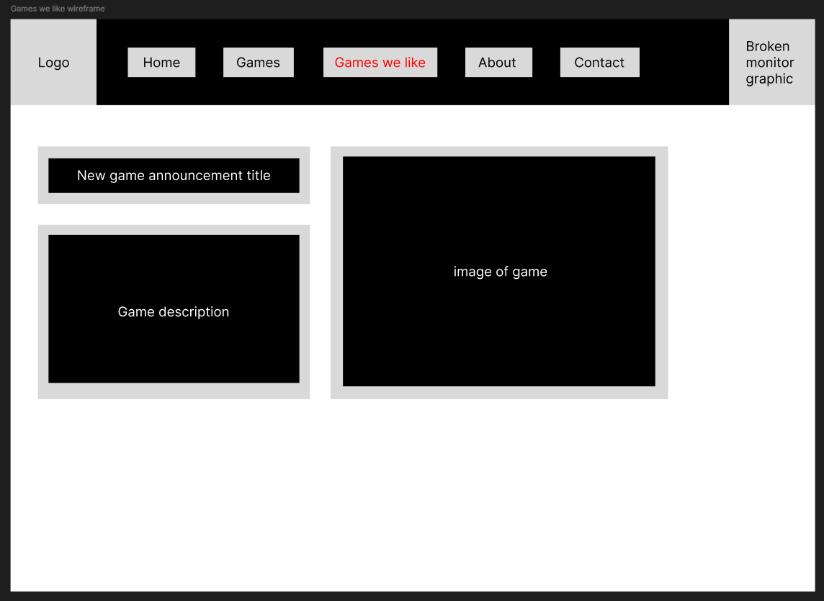

# Part 2:

## Improvements to part 1:

-2024/09/12-

# Added referencing for official IIE documents used for this project [UNDER CONSTRUCTION]

# Changed margin size for word document to “Narrow”

# Removed large empty enter space portions within the word document

-2024/09/26-

# Created wireframes in Figma and added them to the document

# Created graphics for the website